React.js Component Creation

Details:-Assignment-2

Name-Sk.Nure musabbir

Roll no-208x1a4239

College-Kallam haranada reddy institute of technology

source code :

CARD COMPONENT : 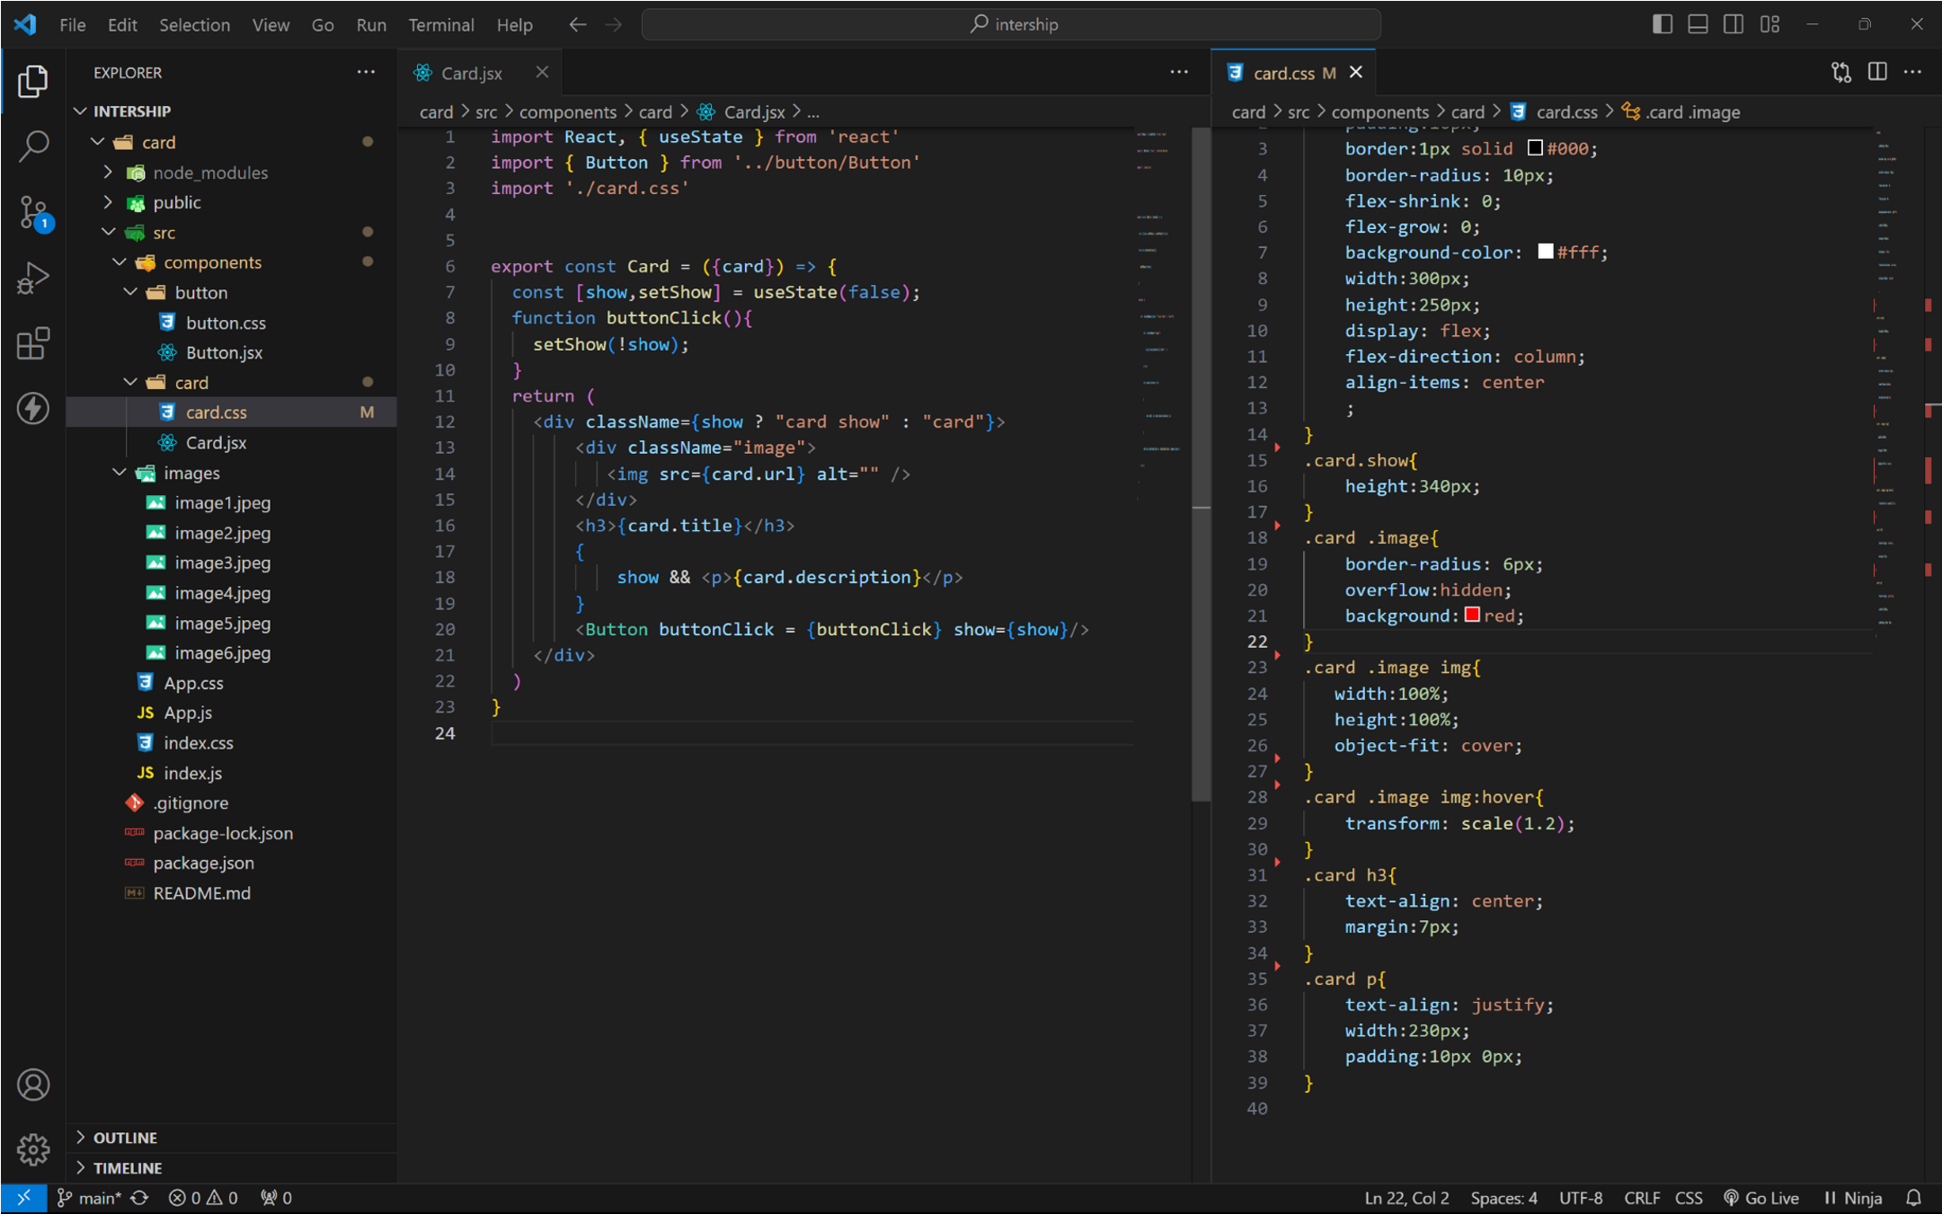

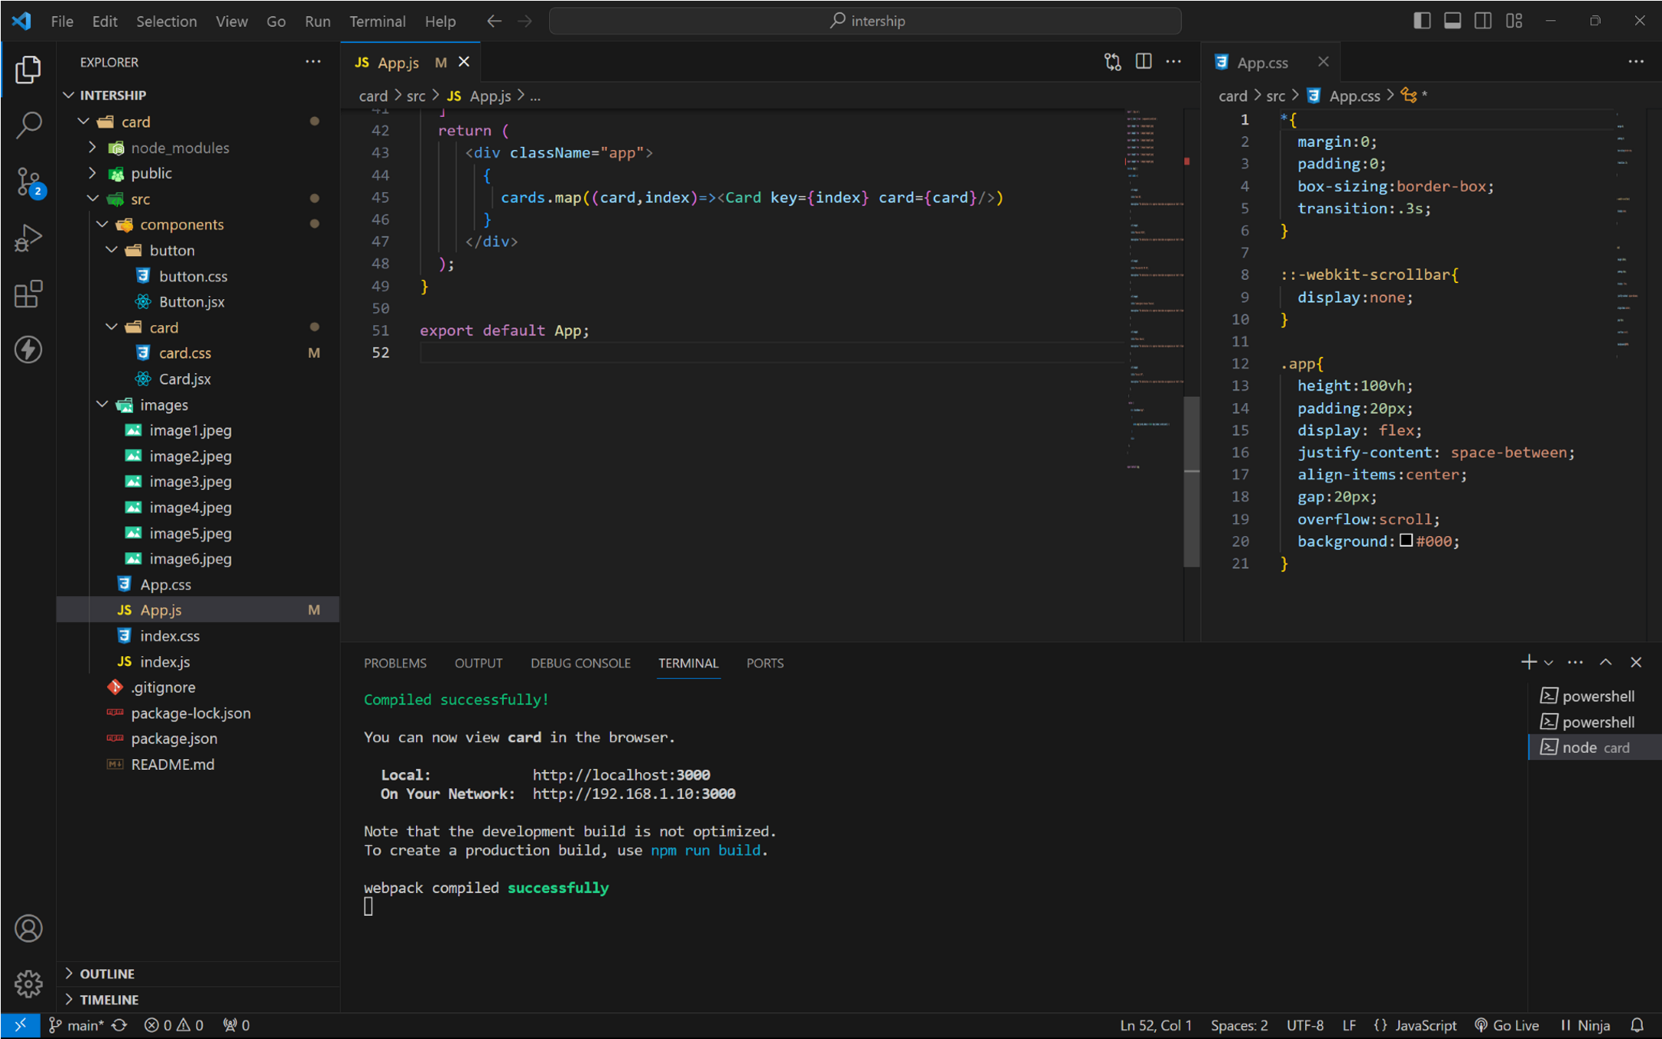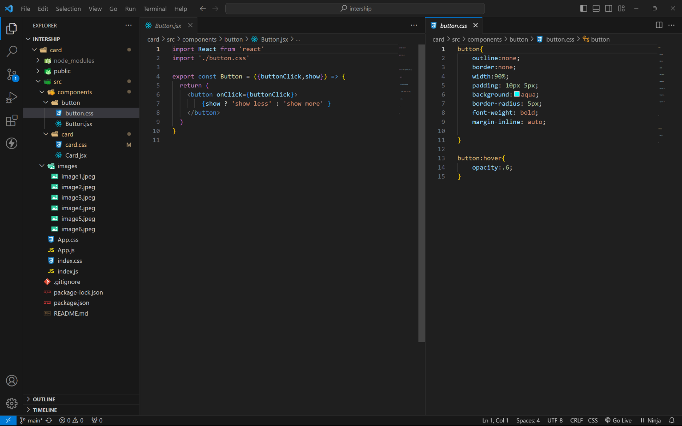BUTTON COMPONET :

APP COMPONENT : 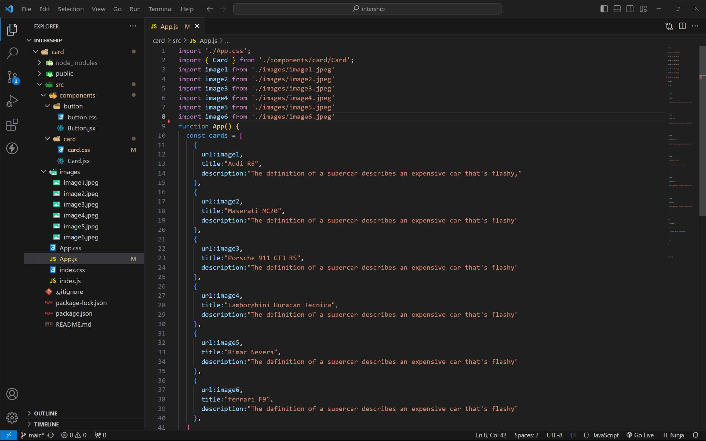 approach :

1. initially taking an array of objects like below

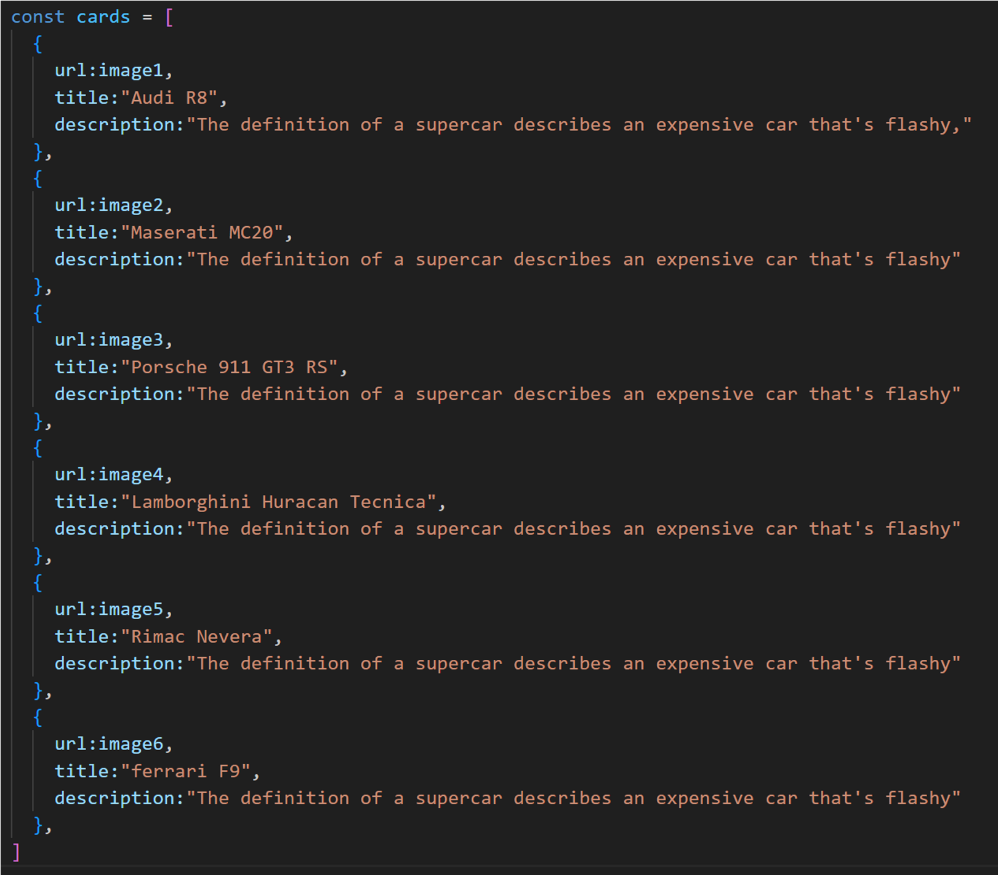

1. . Passing this card array to child (card component) of App component by using props;
2. . getting data as argument like {card} in card component.
3. . in card component i use one state [show, setShow] to get extra info as

description.

1. . When we click the button then show becomes true by assigning setShow (!show) .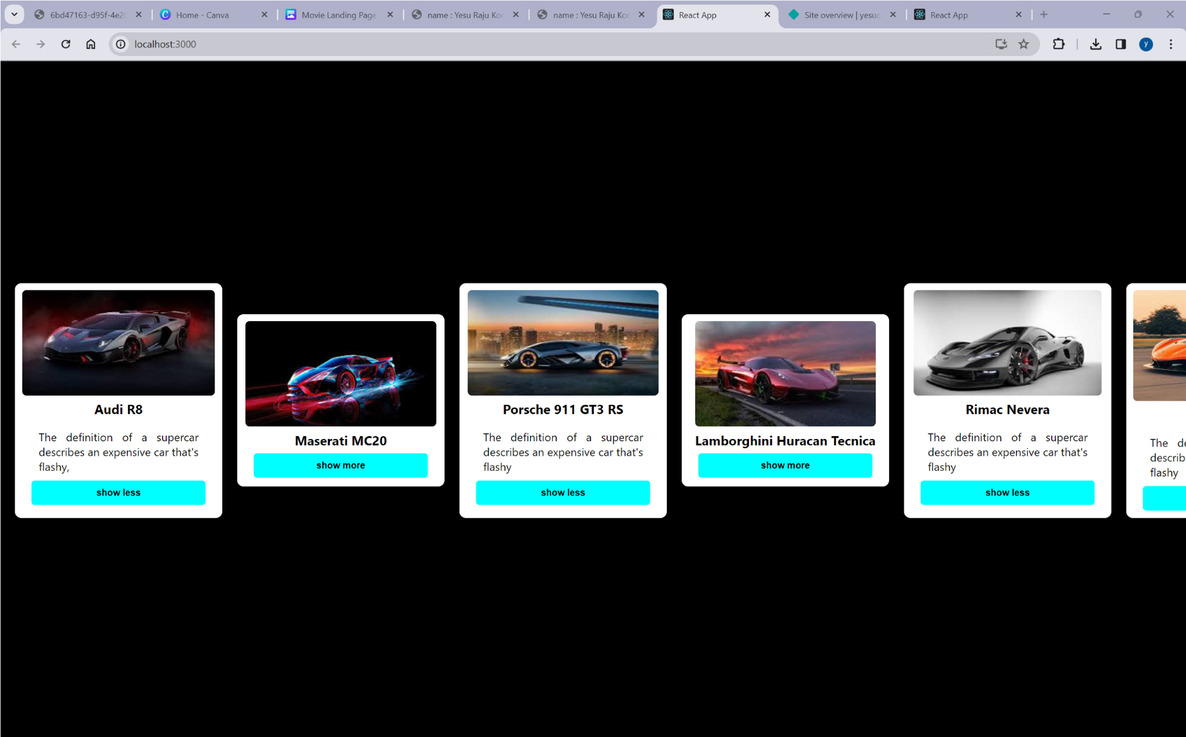

OUTPUT 